 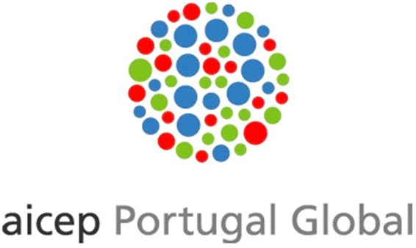

**INVEST IN PORTUGAL-*THE RIGHT TIME, THE RIGHT CHOICE***

**April 14, 2016, River Plaza Istanbul**

**Draft Agenda**

**09:30-10:00 Registration**

**10:00-10:30 Welcoming Remarks**

* Mrs. Berna İlter, Chairperson, DEİK / Turkey – Portugal Business Council
* H.E. Jorge Cabral, Ambassador of Portugal in Ankara

**10:30-11:30 Presentation**

“Invest in Portugal, The Right Time, The Right Choice”

* Mr. Luis Castro Henriques, Board Member, AICEP

**11:30– 12:30 Q&A / Networking Session**