|  |  |  |
| --- | --- | --- |
| C:\Local data LWAL\Lutz Documents\ETP\Documents and Publications\Pictures\ETP Logo\p32845-etp-logo-powerpoint-4-3small.jpg | **European Textile Technology Marketplace**  **ETTMa**  ***Call n° 05: May 2014*** |  |

**Response Form for Industry Searches**

*ETTMa call n° 05: May 2014,* ***Deadline 12 September 2014***

|  |  |  |  |  |  |  |  |  |  |  |  |  |  |
| --- | --- | --- | --- | --- | --- | --- | --- | --- | --- | --- | --- | --- | --- |
| **Identification** | | | | | | | | | | | | | |
| Organisation Name | | | | | | |  | | | | | | |
| Country | | | | | | |  | | | | | | |
| **Technology Solution Proposed** | | | | | | | | | | | | | |
| Industry Search (n° & short title)[1] | | | | | |  | | | | | | | |
| *Description of the proposed solution[2] (max. 300 words):* | | | | | | | | | | | | | |
| Own assessment technology readiness level of the proposed solution (1 to 9)[3] | | | | | | | | | | | | |  |
| Type of demonstration available *(please mark with a cross)[4]* | | __ Detailed technical description of concept/technology/prototype incl. graphical/visual material  __ Availability & access to physical samples/physical lab-scale prototype  __ Availability & access to functional small industrial scale system  __ Availability & access to full-scale industrial installation | | | | | | | | | | | |
| Proposed further follow-up | | | | | | | | | | | | | |
| *Please mark with a cross:*  __ We are available to engage with the company to better understand the issue and identify potential solutions  __ We can bring the company in contact with a provider of a solution to their problem and can assist in further engagement with this provider (if needed)  __ We are available for co-development with the company to reach industrial maturity of the proposed concept/technology  __ We are available to assist the company to bring together all elements for an industrial realisation of the proposed concept/technology  __ We believe we are able to deliver (& install) an industry-ready system | | | | | | | | | | | | | |
| Estimated time to solution | | | | | __less than 1 year __1-2 years __more than 2 years | | | | | | | | |
| Languages for technical interaction (in order of preference) | | | | | | | | | |  | | | |
| **Contact for this technology proposal[5]** | | | | | | | | | | | | | |
| Title | Mr/Ms/Dr/Prof | | | First name | | | |  | | | Name |  | |
| Function/Department | | |  | | | | | | | | | | |
| E-mail address | | |  | | | | | | Direct phone number | | |  | |

The completion of all yellow fields is mandatory. Please remove footnotes after completion.

Please return the completed form in Word format until 12/09/2014 electronically to [**info@textile-platform.eu**](mailto:info@textile-platform.eu)

1. Please provide the number & short title of the industry search to which you respond (e.g. IS3 Efficient Textile Manufacturing Technologies)
2. Please try to make this description as clear and explicit as possible addressing specifically the company search description and additional criteria (if mentioned)
3. Please realistically assess the technology readiness level (TRL) of the offered technological solution. Please refer to the following table for correct level numbering:

   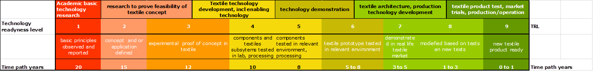

   (source: Brinks, Saxion)
4. Several answers possible
5. The email address is absolutely compulsory as all information exchange will be electronic. A direct phone number could be helpful if the company wants to quickly clarify any point with you.