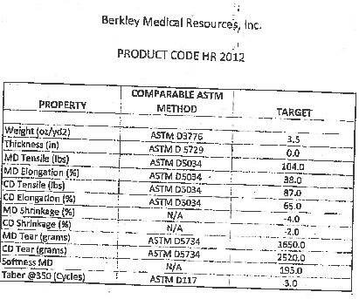

COMPANY PROFIL
NAME OF THE COMPANY:
ADDRESS:
PHONE:
FAX:
E-MAIL:
WEB:
CONTACT PERSON:
STATUS OF THE COMPANY:

(Please specify; “PRODUCUER-EXPORTER”, “EXPORTER”, or “PRODUCER”
ITEMS PRODUCED:
(Please explain your product, for example wollen blanket, cotton blanket, etc.)
PRODUCTION CAPACITY (2011):

(kg/week, ton/year, etc. Please explain)

